**LAPORAN PRAKTIKUM**

Nama : Maftuchati

NIM :18090015

Kelas : 5B

**PRAKTIKUM 5**

1. Source Code

* Autoload.php -> application / config.php

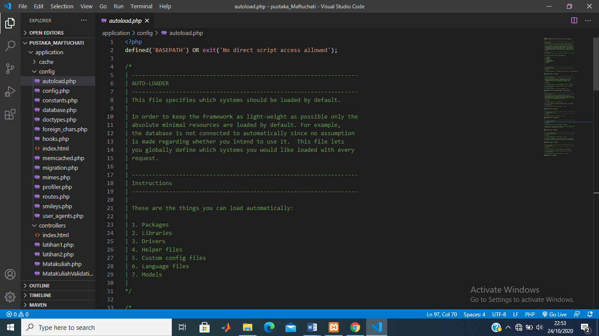

* MatakuliahValidation.php -> application / controller

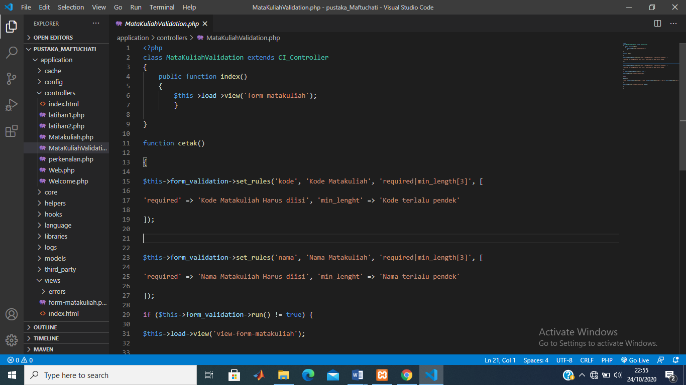

* View-form-matakuliah.php -> application / views

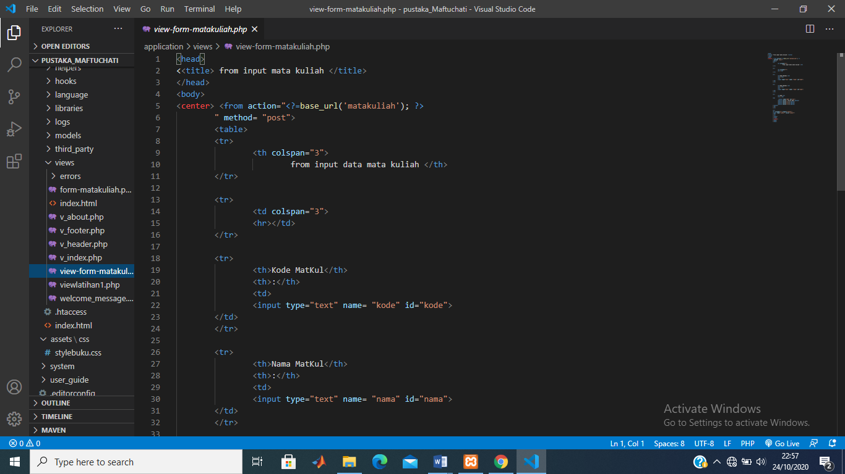

1. URL

<http://localhost/pustaka_eli/index.php/MatakuliahValidation>

1. Capture Hasil

